|  |
| --- |
| **DETAIL DESIGN DOCUMENT** |
| DD_EmployeeManagement |
| Version 1.0, issued date 4/10/2012 |
|  |
|  |
|  |
|  |
|  |

Contents

1. File list 3

2. Function list 3

3. Detail Design 5

3.1. Client Class Diagram 5

3.2. Business Class Diagram 5

3.3. Entity Diagram 6

3.4. Sequence Diagram 7

3.4.1. List Artical Management Diagram 7

3.4.2. Edit Artical Management Diagram 8

1. **File list**

[*Reference to Employeemanagement in File List*](../../HRM_File%20List.xlsx)

1. **Function list**

|  |  |
| --- | --- |
| ***ListEmployeeManagementView*** |  |
| **Function** | **Description** |
| OnCellDoubleClick() | Show GUI choosen by user |

|  |  |
| --- | --- |
| ***EditEmployeeManagementView*** |  |
| **Function** | **Description** |
| View_CloseWindow() | Close GUI choosen by user |

|  |  |
| --- | --- |
| ***EditAddressView*** |  |
| **Function** | **Description** |
| View_CloseWindow() | Close GUI choosen by user |

|  |  |
| --- | --- |
| ***EditBirthPlaceView*** |  |
| **Function** | **Description** |
| View_CloseWindow() | Close GUI choosen by user |

|  |  |
| --- | --- |
| ***UploadEmployeeView*** |  |
| **Function** | **Description** |
| View_CloseWindow() | Close GUI choosen by user |

|  |  |
| --- | --- |
| ***ListEmployeeManagementViewModel*** |  |
| **Function** | **Description** |
| GetListEmployeeManagementComplete() | Get list of available data of Employeemanagement to List View |
| GetEmployeeManagementtByKeyComplete (string keyName) | Check EmployeeManakey inserted with available EmployeeManakey in database. |
| DeleteEmployeeManagementComplete(int id) | Delete list data of Employeemanagement from database |
| Reload() | Get available data of Employeemanagement from database |
| LoadInitComplete() | Display data from Reload() to List View |

|  |  |
| --- | --- |
| ***EditEmployeeManagementViewModel*** |  |
| **Function** | **Description** |
| SaveEmployeeManagementComplete(int id) | Store data of EmployeeManagement to database |
| GetEmployeeManagementComplete(int id) | Get list of available data of Employeemanagement to Edit View |
| GetEmployeeManagementByKeyComplete(string keyName) | Check EmployeeManakey inserted with available EmployeeManakey in database. |
| CheckInputData() | Check if user input wrong data or lack |
| Readload() | Get available data of Employeemanagement from database |
| LoadInitComplete() | Display data from Reload() to List View |

|  |  |
| --- | --- |
| ***ExpandInformationModel*** |  |
| **Function** | **Description** |
| GetListEmployeeManagementAsync(int id) | Get list of available data of Employeemanagement from database to ViewlModel |
| GetEmployeeManagementAsync(int id) | Get data of Employeemanagement from database. |
| SaveEmployeeManagementAsync(int id) | Insert data of Employeemanagement to database. |
| DeleteEmployeeManagementAsync(int id) | Remove data of Employeemanagement to database. |

|  |  |
| --- | --- |
| ***HRMService*** |  |
| **Function** | **Description** |
| GetHRM_EmployeeManagement(int id) | SQL statement is generated from ViewModel player and dispatch to this layer to execute Select transaction. |
| InsertHRM_EmployeeManagement(int id) | SQL statement is generated from ViewModel player and dispatch to this layer to execute Insert transaction. |
| UpdateHRM_EmployeeManagement(int id) | SQL statement is generated from ViewModel player and dispatch to this layer to execute Update transaction. |
| DeleteHRM_EmployeeManagement(int id) | SQL statement is generated from ViewModel player and dispatch to this layer to execute Delete transaction. |

1. **Detail Design**
   1. Client Class Diagram



* 1. Business Class Diagram



* 1. Entity Diagram

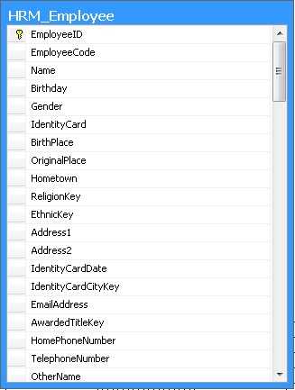

* 1. Sequence Diagram
     1. List Employee Management Diagram



* + 1. Edit Employee Management Diagram

